# VPN gateway Functionalities provided

creating a secure channel. Authenticating users

Providing an IP address (static IP address).

[DNS resolution](https://www.goodaccess.com/blog/vpn-gateway-everything-you-need-to-know#%3A~%3Atext%3DVPN%20gateways%20also%20carry%20out%20DNS%20resolution%20to%20route%20traffic%20over%20the%20internet%2C%20and%20more%20advanced%20gateways%20also%20offer%20DNS%20filtering%20as%20a%20protective%20measure%20against%20phishing%20and%20malware%20attacks) [access control](https://www.goodaccess.com/blog/vpn-gateway-everything-you-need-to-know#%3A~%3Atext%3DLast%20but%20not%20least%2C%20VPN%20gateways%20can%20also%20handle%20access%20control%2C%20which%20consists%20of%20assigning%20access%20rights%20to%20users.%20This%20can%20be%20a%20powerful%20security%20tool%20of%20limiting%20access%20to%20applications%20and%20thus%20significantly%20reducing%20the%20risk%20of%20cyber%20threats%20and%20their%20impact)

**!** Creating secure channels between users, networks, or systems over the internet.

The way tunnel is established and secured depends on the selected **VPN protocol**, such as openVPN, IPsec, or IKEv2.

**?** secure access to local systems for remote users would often be encrypted via the **IKEv2 protocol**.

**?** site-to-site connections connecting two branches would rely on the **IPsec protocol**.

**?** modern protocols, like OpenVPN or Wireguard are equally suited for all VPN use cases.

Another task of VPN gateway is authenticating users. [authentication process](https://www.goodaccess.com/blog/vpn-gateway-everything-you-need-to-know#%3A~%3Atext%3DWhen%20a%20user%2Cfor%20better%20security)

# Requirements to create P2S

**VPN gateway** - need to attach to the Vnet where the VM exists.

whenever we connect Gateway with a Vnet. **we require a *GatewaySubnet*** subnet connecting between Gateway with the Gateway Subnet.

Need to give an **IP pool** (IP range) to the VPN gateway, one IP is assigned to the Local machine.

Then both VPN gateway and Local machine will be in the same network. Connection established

Need an **Authentication process** to connect the VPN gateway.

In youtube (self Signed Root Certificate - authentication process) inside the VPN gateway. Create a **Client Certificate** - deployed in the local machine.

Need a **VPN client** (software) installed in the Local machine to initiate the VPN connection. now VPN gateway is a gateway to enter inside the Vnet.

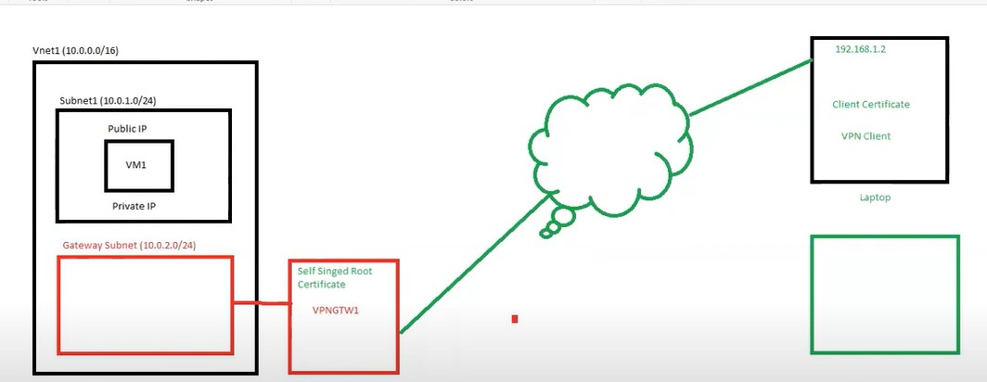

# Self Signed root certificate

powershell script

$params = @{

Type = 'Custom'

Subject = 'CN=P2SRootCert' KeySpec = 'Signature'

KeyExportPolicy = 'Exportable'

KeyUsage = 'CertSign'

KeyUsageProperty = 'Sign' KeyLength = 2048

HashAlgorithm = 'sha256'

NotAfter = (Get-Date).AddMonths(24)

CertStoreLocation = 'Cert:\CurrentUser\My'

}

$cert = New-SelfSignedCertificate @params

Locating the certificate - **certmgr.msc**, console to manage your certificates

**Personal** > **Certificates**

P2SRootCert file is created (valid for 1 year)

Exporting - right-click > All tasks > Export > NExt > Next > Base-64 encoded, 509 (.CER)

# Generate a Client Certificate

PowerShell script

$params = @{

Type = 'Custom'

Subject = 'CN=P2SChildCert' DnsName = 'P2SChildCert'

KeySpec = 'Signature'

KeyExportPolicy = 'Exportable' KeyLength = 2048

HashAlgorithm = 'sha256'

NotAfter = (Get-Date).AddMonths(18)

CertStoreLocation = 'Cert:\CurrentUser\My' Signer = $cert

TextExtension = @(

'2.5.29.37={text}1.3.6.1.5.5.7.3.2')

}

New-SelfSignedCertificate @params

Exporting - **Export the private key** > create a password > and save it. extention - **.pfx**

# Download VPN client

unzip it.

run the exe as administrator

# important resources

[About Azure VPN Gateway | Microsoft Learn](https://learn.microsoft.com/en-us/azure/vpn-gateway/vpn-gateway-about-vpngateways) [VPN protocols compared](https://www.goodaccess.com/blog/vpn-protocols-compared)

[IP Whitelisting](https://www.goodaccess.com/ip-whitelisting)

[active-active, actice-standby](https://learn.microsoft.com/en-us/azure/vpn-gateway/design#%3A~%3Atext%3DVPN%20Gateway%20can%2Cexperience%20higher%20throughputs)